August 17, 2017  9:00 PM EST | Kenny McKee  High School Literacy Coach  Buncombe County Schools | New Goals for a New Year
September 21, 2017  9:00 PM EST | Dr. Rob Jackson  Superintendent  Edenton-Chowan Schools | Positive Learning Environments
October 19, 2017  9:00 PM EST | Angela Hill  Principal  The Capitol Encore Academy | Arts Integration
November 16, 2017  9:00 PM EST | Dr. Julie Spencer  Assistant Superintendent  Durham Public Schools | How Data Helps Schools and Districts
January 18, 2018  9:00 PM EST | Kyle Hamstra  STEM Specialist  Wake County Public School System | Enhancing student Learning Experiences
February 15, 2018  9:00 PM EST | Jusmar Maness  Principal  Guilford County Schools | Supporting EL Families
March 15, 2018  9:00 PM EST | Kathy Walker  Assistant Principal  Iredell-Statesville Schools | Operational Side of Blended Learning
April 19, 2018  9:00 PM EST | Dr. David Fonseca  Assistant Superintendent  Burke County Schools | Using Electronic Collaborative Lesson Planning Tools
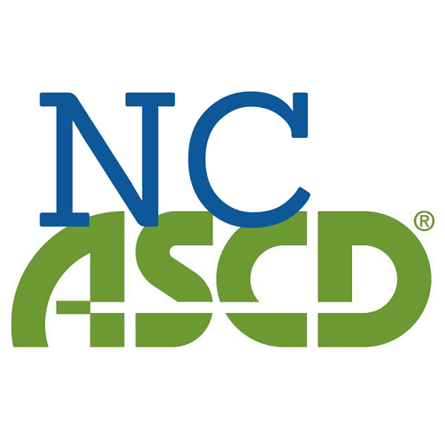

Twitter Chats 2017-2018

