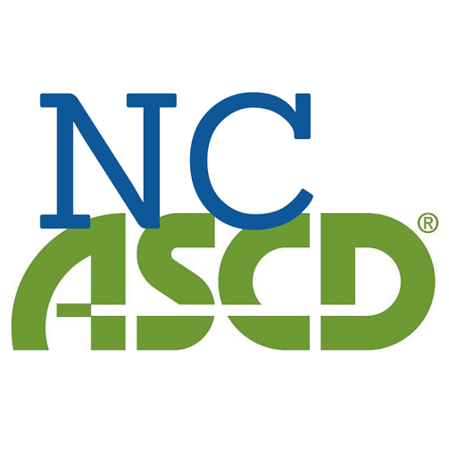

NCASCD Newsletter Article Guidelines

NCASCD Members are preferred authors. If you don’t know if you are a member of NCASCD, contact Dr. Lillie Cox at Lillie.ncascd@gmail.com.
1500-2500 words is the appropriate length
Articles describing research-based solutions to current problems in education.
Original content not previously published elsewhere
Use of citations where appropriate
Reasoned debate on controversial subjects.
Opinion pieces that interweave experiences and ideas.
Program descriptions (school, district, or state).
Practical examples that illustrate key points.
An emphasis on explaining and interpreting research results rather than on methodology.
Vendors may advertise on a limited basis per newsletter issue. Contact Dr. Lillie Cox at Lillie.ncascd@gmail.com for information.

We are not interested in articles that are merely celebratory of school or district achievements. While student or educator success may be a part of the article, the research and reasoning behind it should be the focus of the writing.
Email articles to Dr. Lillie Cox at Lillie.ncascd@gmail.com by the deadline.

