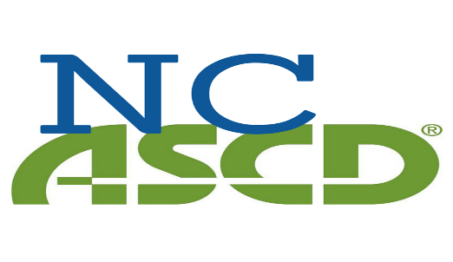

Annual Individual Membership $45

Name: _________________________________________Date: _______________________________

Address: _____________________________________________________________________________
_____________________________________________________________________________________
Email: _______________________________________________Phone: __________________________
Title/Job:________________________________School:_______________________________________
District/Organization: ___________________________________________________________________

Individual memberships are good one year from the date received. You will receive an email confirming receipt.

Mail payment to:
NCASCD
PO Box 220791
Charlotte NC 28222

